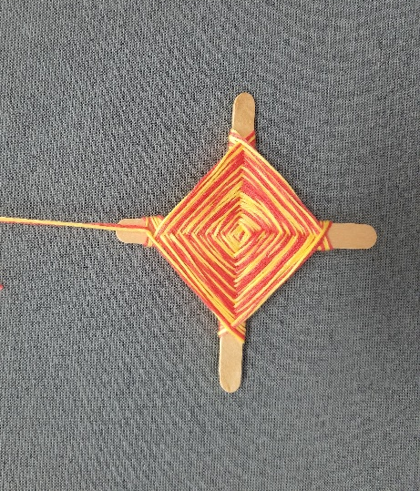
God’s Eye

Supplies included:

- 2 popsicle sticks
- Embroidery yarn (1 bundle)

Instructions

- Cross the two popsicle sticks to form an “x”
- To secure the sticks and keep them in place, begin by wrapping your yarn around the intersecting points of the sticks. Do a few wraps in one direction, then turn the sticks around and do a few wraps in the opposite direction until the sticks feel secure.
- Next, wrap your yarn around one stick and then move it over to the next stick and wrap it around that, going over each stick.
- Rotate around, wrapping the yarn around each stick until you reach the end (about an inch from the end of the sticks.)
- Stop weaving and wrap the yarn around one stick a few times, making sure to leave enough yarn to tie a hole to form a circle (so you can hang your craft).

Watch the video on the CLPL YouTube Channel for expanded directions: https://youtu.be/4g27T8VlSAo

